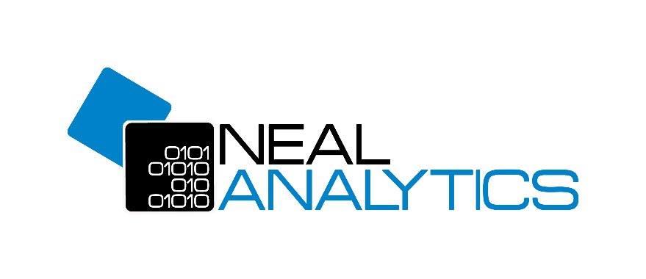

Azure Devops Analytics Dashboard

User Guide

Abstract

*Steps & detailed guide to use Azure DevOps Dashboard*

Table of Contents

**1** **Introduction** 2

**2** **Pre-requisites** 2

**3** **Configuration on DevOps** 3

**4** **Configuration on Power BI App** 4

**5** **Best Practices & Steps** 6

**1 Introduction**

With Power BI Desktop, you can easily connect to an Analytics view to start creating reports for your project in Azure DevOps. An Analytics view provides a simplified way to specify the filter criteria for a Power BI report based on Analytics data. Using a holistic view of the current and historical iteration details you will get a dashboard readily available to see all details easily in one place. The Azure DevOps Analytics Dashboard will help to assess the month-over-month iteration health and status of the Project. Using the Azure DevOps Analytics Dashboard one can examine the data from many different angles and can easily compare multiple iterations and combine and see details for the whole.

**2 Pre-requisites**

Before you connect to Azure DevOps. Ensure you are granted the View Analytics for the project.

From the web portal for Azure DevOps, click on the Overview button then select the Analytics view option from the dropdown list.

If you don’t see the Analytics View option, then enable it from the preview feature. You can find the detailed solution step by step here-

<https://docs.microsoft.com/en-us/azure/devops/project/navigation/preview-features?view=azure-devops&tabs=new-account-enabled>

1. **Configuration on DevOps**

In the Analytics view, you have to change the settings of these 3 tables given below-

Stories – All history by month

Tasks – All history by month

Work Items – All history by month

After clicking on the above view you will see some information and contents of the view you have to make sure that History is Current only and in the fields all fields should be added, to add all fields click on the Edit option. You have to do this with all the three views Stories – All history by month, Tasks – All history by month, Work Items – All history by month

Add all the available fields don’t miss a single field or else you will get AN ERROR in power Bi (Schema is not matching)

1. **Configuration on Power BI App**

After making changes in the analytics view in Azure DevOps open the Azure DevOps Analytics App. When you open the App you have to put the Organization name and Project name correctly into the Parameters to load your Project views.

Follow the steps given below-

1. Sign-in to your Power BI account.
2. You may get an error message as below once you are signed in. If you do not get the below error and you get an installation option, please move to step 3.

If you do have this error message, then please follow these sub steps –

• You need to ask the Power BI service administrator to enable the template app installation permissions.

• The administrator can give you the permissions by going over to the Admin Portal on the Power BI Services.

Once we move into the Admin Portal we should see the same options as the image above. Select ‘Tenant Settings’.

With this setting, everyone in your organization will be able to access and install Template Apps. Note - It can take up to 10 minutes for a setting change to take effect for everyone in your tenant.

1. Click on Install

1. Your template app will be shown here.

1. Click on the app and it will open the report. Once you open a report it shows you the report with *sample data* and warning that *“You’re viewing this app with sample data. Connect your data”*

1. Click on “Connect your data” and it will show you following dialogue box for editing parameter.

1. Type your Project Name and Organization and click on Next.

1. Authenticate yourself and connect to the project.

1. Once the authentication process is done, report data will be refreshed and it will show the actual data instead of sample data.

**5 Best Practices & Steps**

For getting the best results you should follow some steps from the start of the project.

1. Make proper sprints and add correct sprint dates.
2. Create stories and tasks also put Assigned to members and estimated hours for the task
3. Most important update the worked hours regularly for sprint analysis.
4. Also, remember to close the task and story after completion.
5. Create Sprints with the right Sprint dates mentioned. Below are the steps to add Sprints in DevOps-

1. Create User Stories for grouping the tasks and remember to add correct story points for each user story. There are some points which are highlighted in yellow you have to fill them properly for getting best results from the report. Below are the steps given to create a user story and how can you add story points to user stories -

1. After creating a user story it’s time to add some tasks into it. Below are the steps you can follow to create the tasks. For tasks, the key points are Efforts(hours) you must keep updating the hours correctly and regularly.

1. Fill the details shown below for all tasks to do Analysis in PowerBI

